NewsGrid - News Portal

Introduction

Developed an Online News Portal, that allows various users to easily create, read, bookmark and download news articles. Integrated [mPDF](https://mpdf.github.io/), a PHP library which generates PDF files from UTF-8 encoded HTML. Wrote clean, well documented, reusable code and incorporated the best development practices at my best.

Technologies used:

Front end: HTML, CSS, JavaScript, Bootstrap (for Admin Panel only)

Back end: PHP, MySQL

Library: mPDF Library

This project aims to develop a computerized and easy to access the day-to-day news without having to wait. “NewsGrid” is aimed at developing such an efficient website that helps in providing up to date news about various happenings around the world.

[View Demo](https://news-grid.herokuapp.com/)

Demo Credentials

email: demo@demo.com

password: Demo123

[View Screenshots](https://github.com/Anish-U/NewsGrid#project-screenshots)

Module Description

The entire project as a whole can be divided into 4 modules, the four modules being:

[Admin Module](https://github.com/Anish-U/NewsGrid#admin-module)

[Author Module](https://github.com/Anish-U/NewsGrid#author-module)

[Free User](https://github.com/Anish-U/NewsGrid#user-module)

[Premium User](https://github.com/Anish-U/NewsGrid#premium-user-module)

Admin Module

Admin can modify and delete user account and restrict them from entering the logged-in portal of NewsGrid.

Admin can modify and delete Author account and restricting inactive authors from writing new articles on NewsGrid.

Admin can add, modify and delete categories under which various articles are written.

Admin can delete all the News Articles present in the NewsGrid Portal, decides whether the particular article should stay or not.

Admin manages the Trending section of the portal, chooses which article goes under Trending section and is displayed on carousel

Admin can manage his account credentials (i.e.) can change password.

Author Module

Author can write new articles and post in the NewsGrid portal by selecting the appropriate category in which the article is written and to be displayed.

Author can modify and delete articles written by him only.

Author can manage his account credentials (i.e.) can change password & name.

User Module

User can browse through NewsGrid website and search for articles under various categories present in the portal.

User can search for articles based in his preferred categories like Sports, Entertainment, Politics, etc.

User can search for a particular article based on specific keywords like title of the article or category name, trending.

User can sort articles date wise and view articles posted on particular date of choice or between a span of days.

User can also look up the trending articles of the week.

User can manage his account credentials (i.e.) can change password.

Premium User Module

A Premium User can basically do everything a free user can do. User can browse through NewsGrid website and search for articles under various categories present in the portal.

User can search for a particular article based on specific keywords like title of the article or category name, trending, date.

Premium User can download an article of his choice in PDF format from any web browser from NewsGrid Portal.

Premium User can bookmark an article for future references and all the bookmarked articles are visible separately on the Bookmarks Page.

Premium User can manage his account credentials (i.e.) can change password.

Project Screenshots

Home Page

[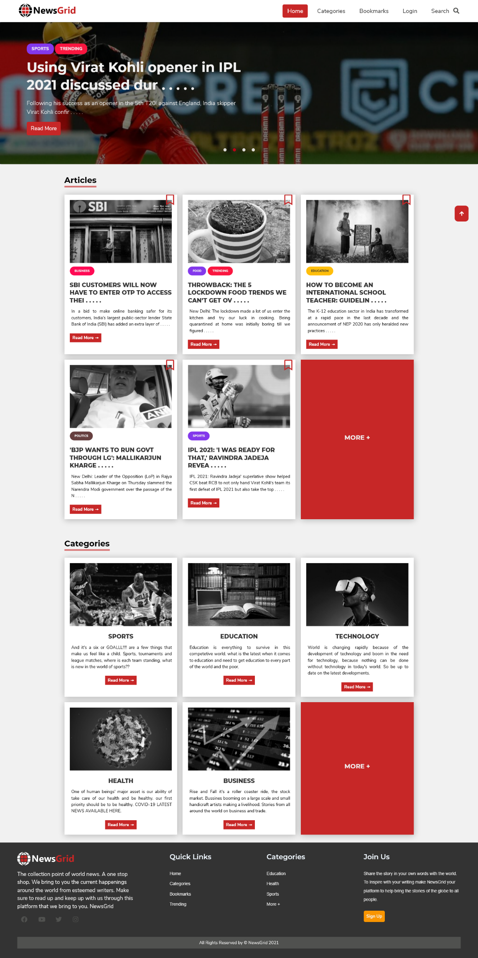](https://github.com/Anish-U/NewsGrid/blob/master/screenshots/home.png)

Categories Page

[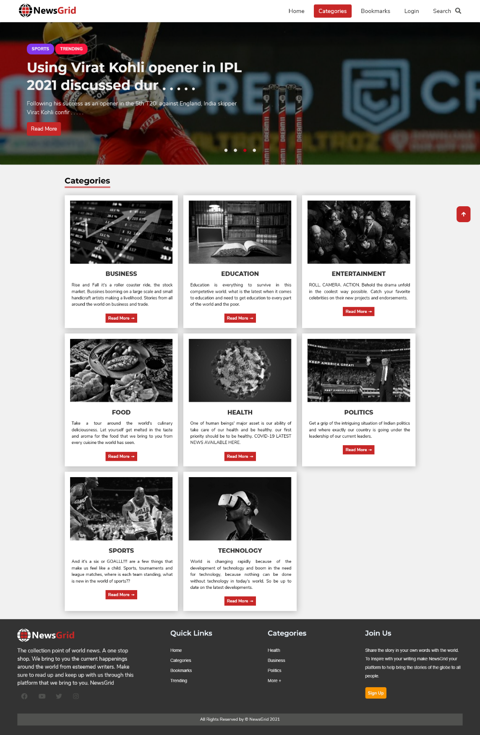](https://github.com/Anish-U/NewsGrid/blob/master/screenshots/categories.png)

Search Page

[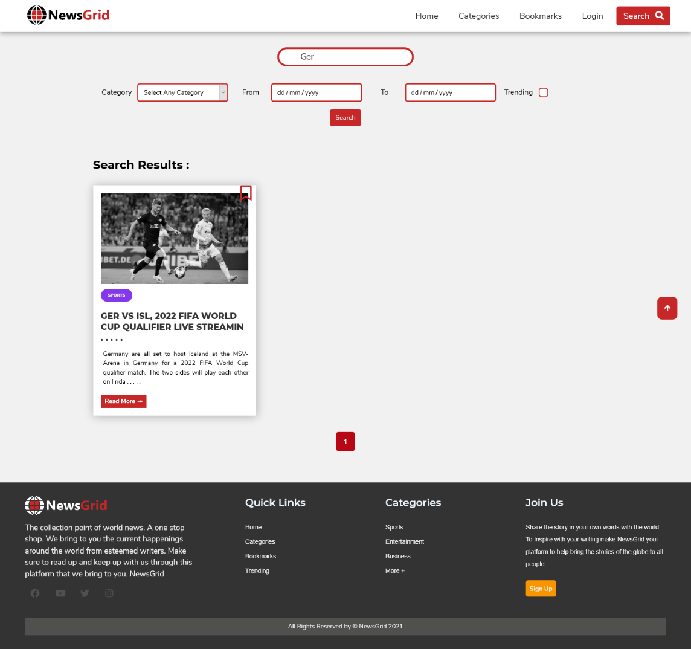](https://github.com/Anish-U/NewsGrid/blob/master/screenshots/search.png)

Login & Signup Page

[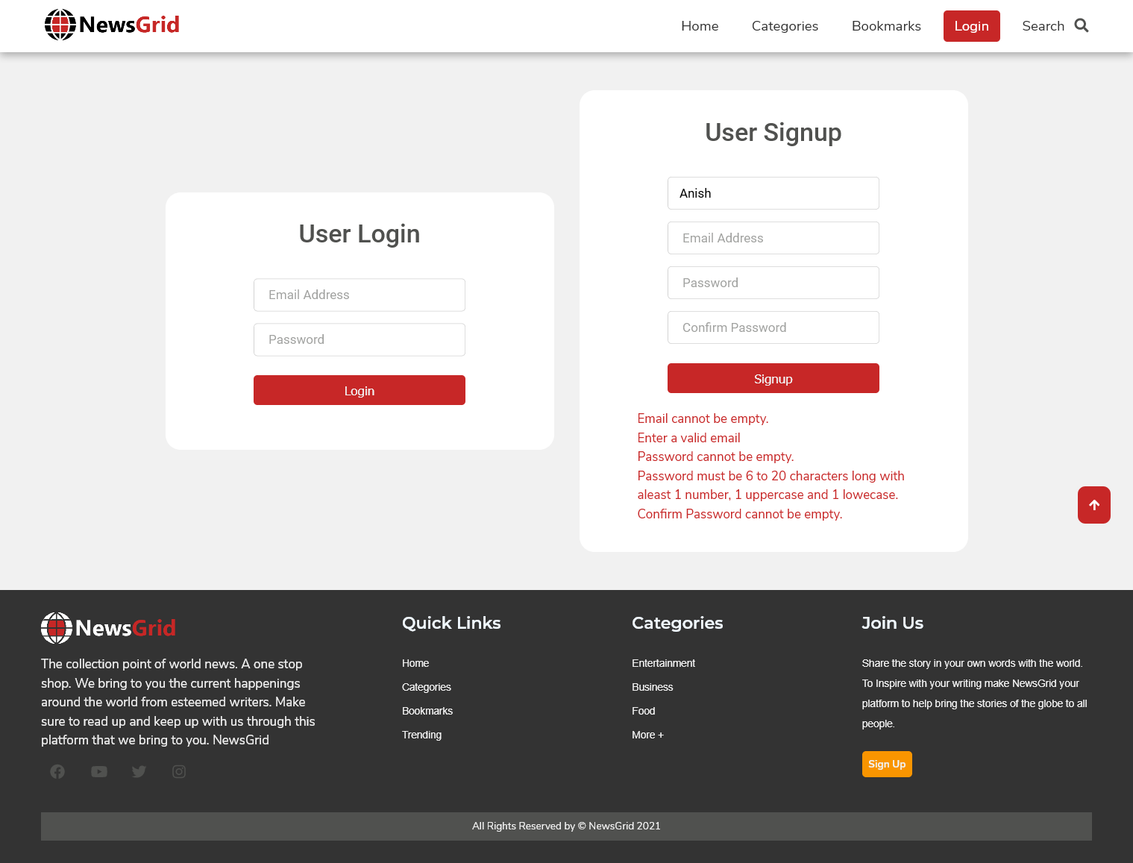](https://github.com/Anish-U/NewsGrid/blob/master/screenshots/login.png)

Bookmarks Page

[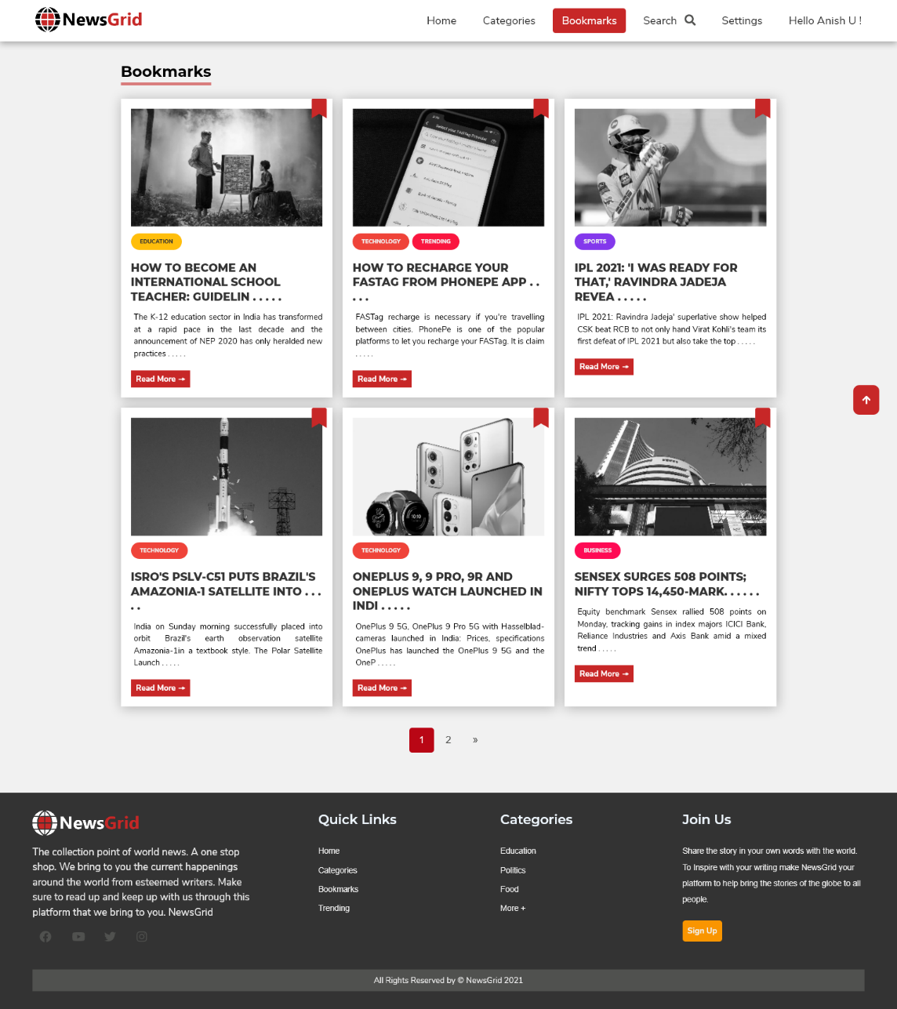](https://github.com/Anish-U/NewsGrid/blob/master/screenshots/bookmarks.png)

Change Password Page

[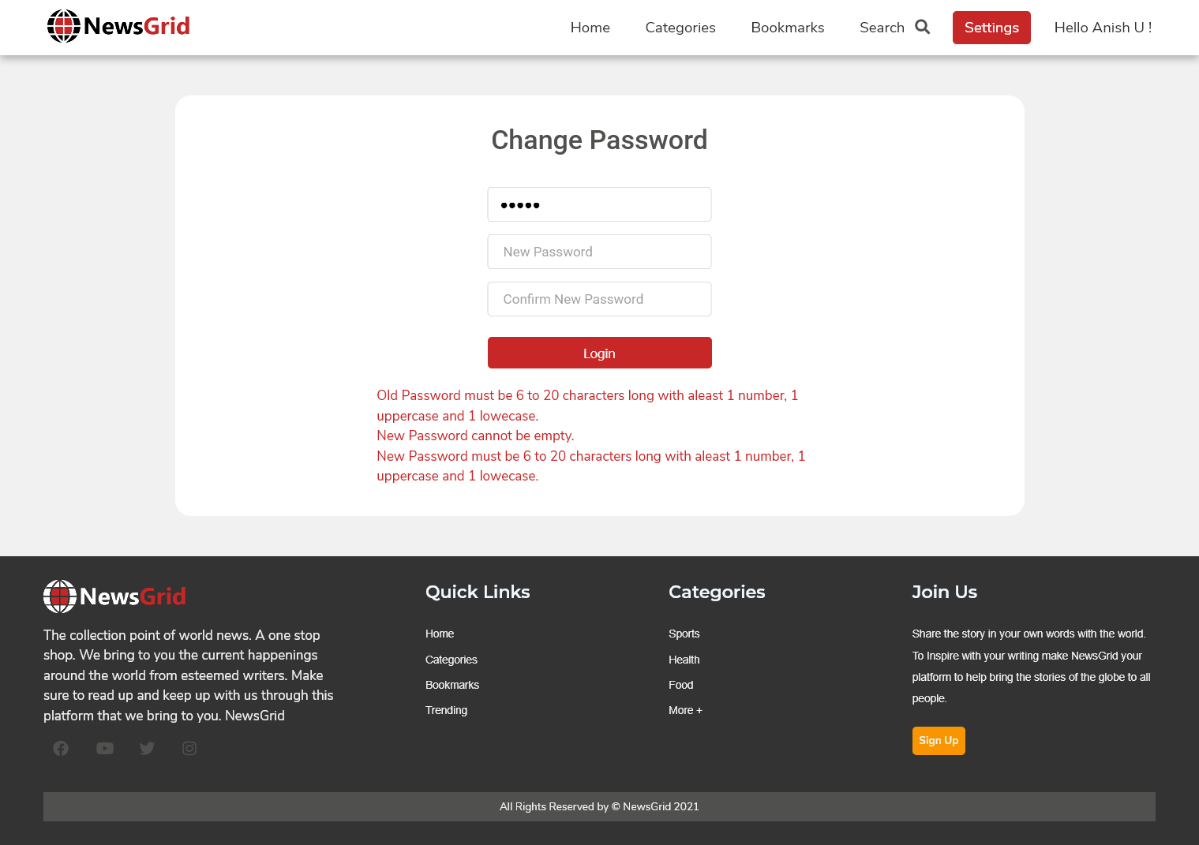](https://github.com/Anish-U/NewsGrid/blob/master/screenshots/changePassword.png)

Author Dashboard Page

[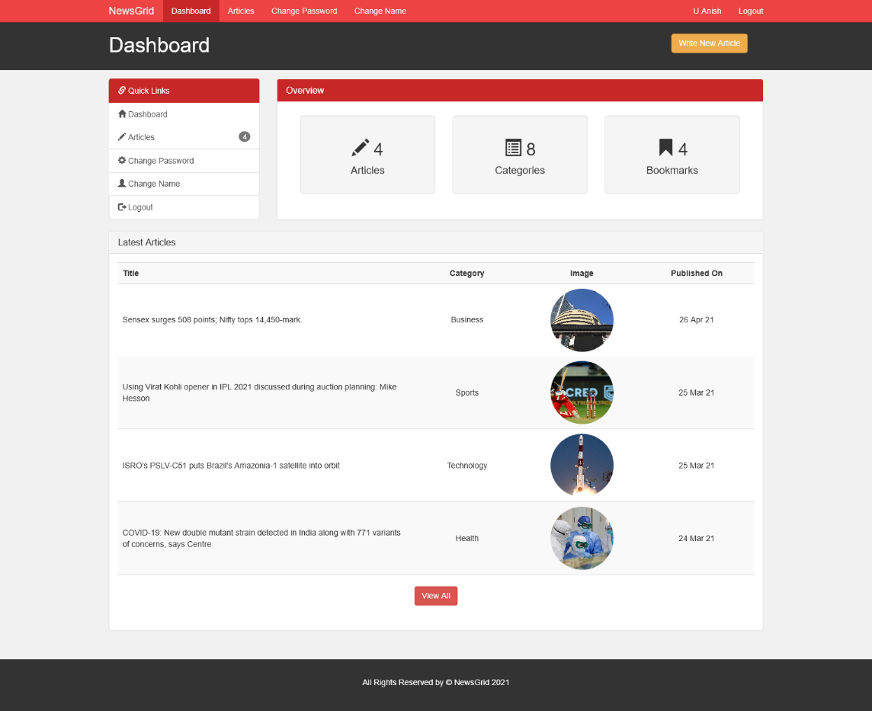](https://github.com/Anish-U/NewsGrid/blob/master/screenshots/authorPanelDashboard.png)

Add Article Page

[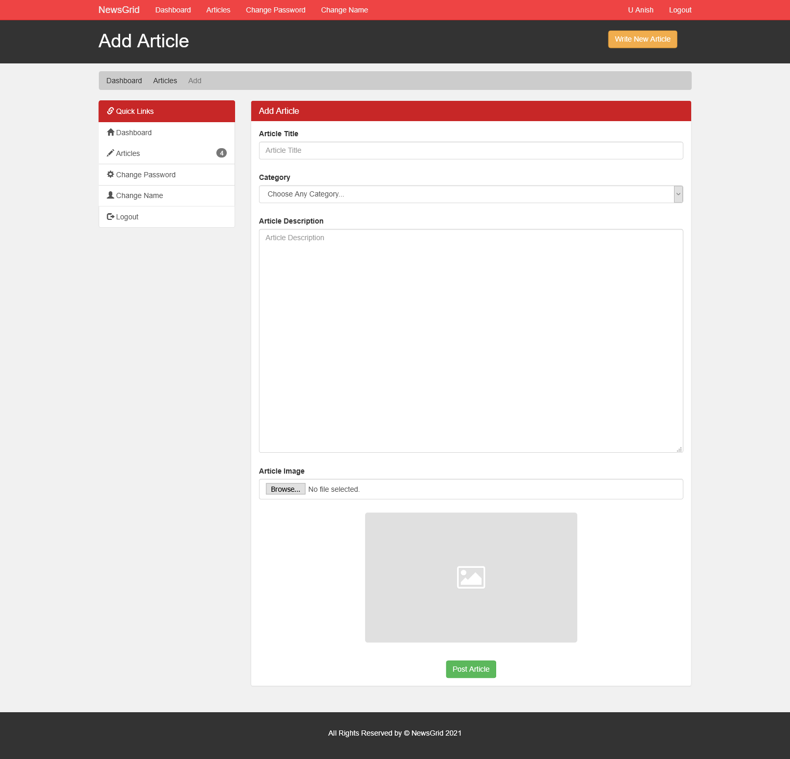](https://github.com/Anish-U/NewsGrid/blob/master/screenshots/authorPanelAddArticle.png)

Edit Article Page

[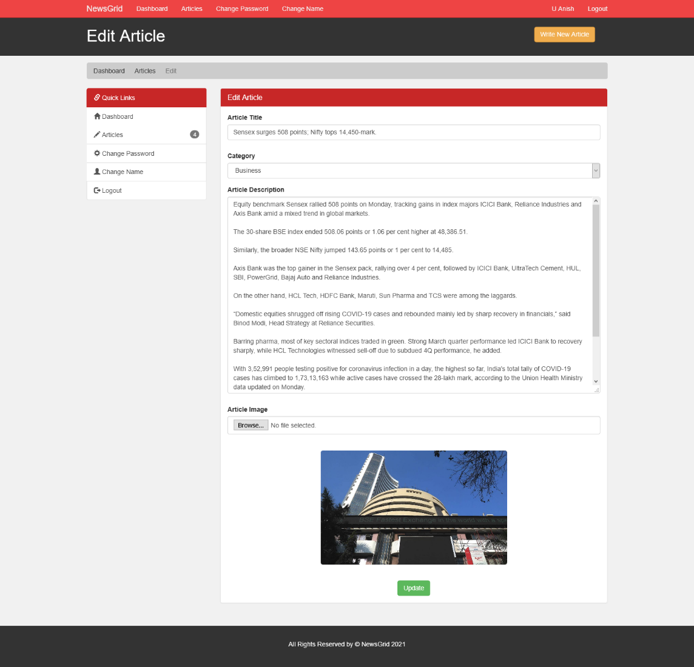](https://github.com/Anish-U/NewsGrid/blob/master/screenshots/authorPanelEditArticle.png)

All Articles Page

[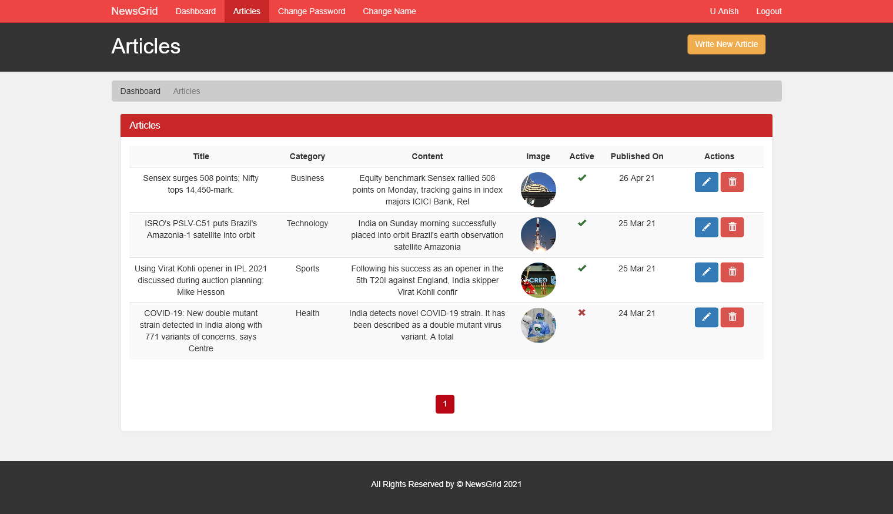](https://github.com/Anish-U/NewsGrid/blob/master/screenshots/authorPanelArticles.png)

Author Change Name Page

[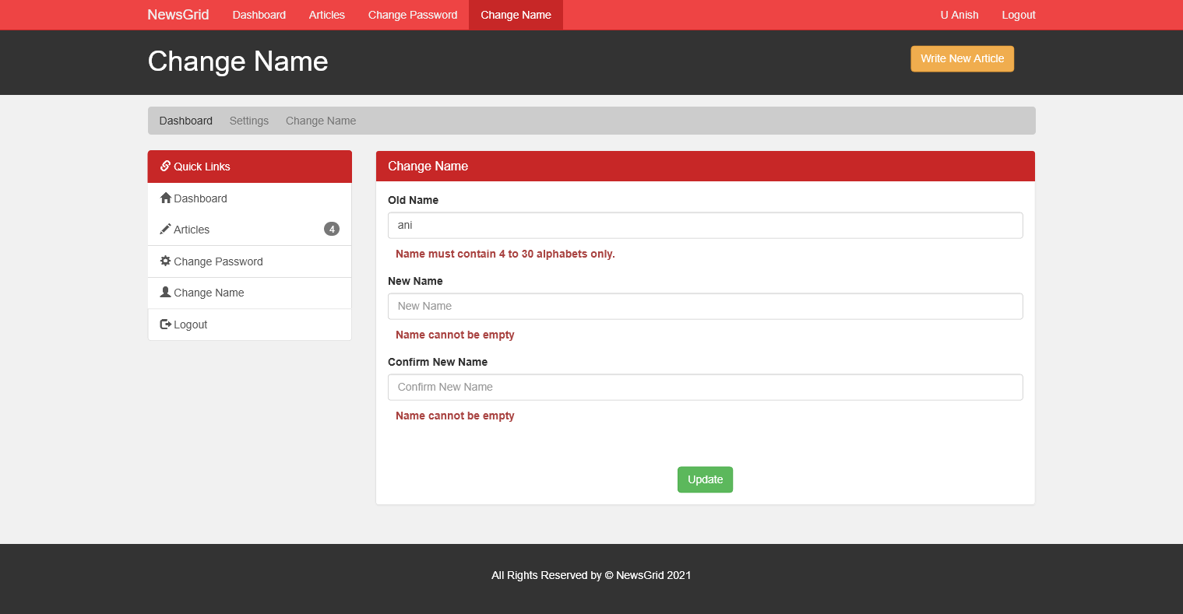](https://github.com/Anish-U/NewsGrid/blob/master/screenshots/authorPanelChangeName.png)

Admin Login Page

[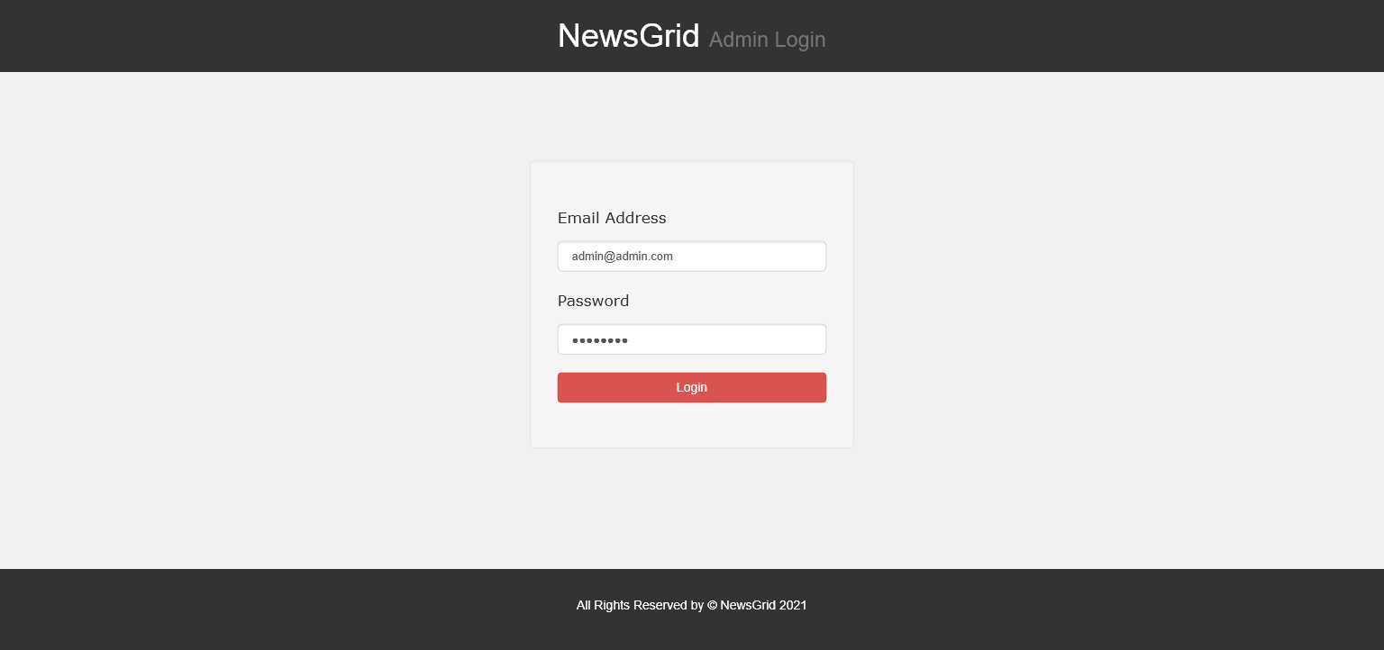](https://github.com/Anish-U/NewsGrid/blob/master/screenshots/adminPanelLogin.png)

Admin Manage Articles Page

[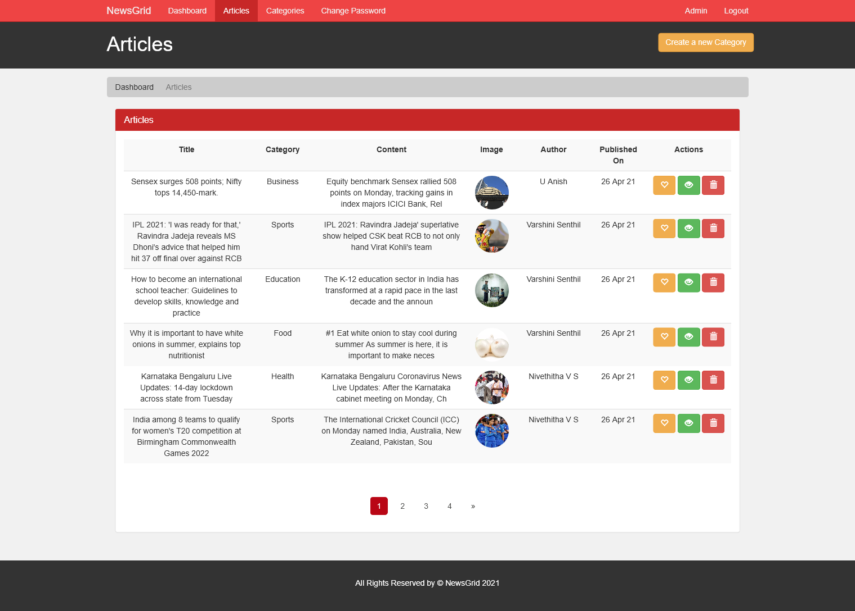](https://github.com/Anish-U/NewsGrid/blob/master/screenshots/adminPanelArticles.png)

Admin Manage Category Page

[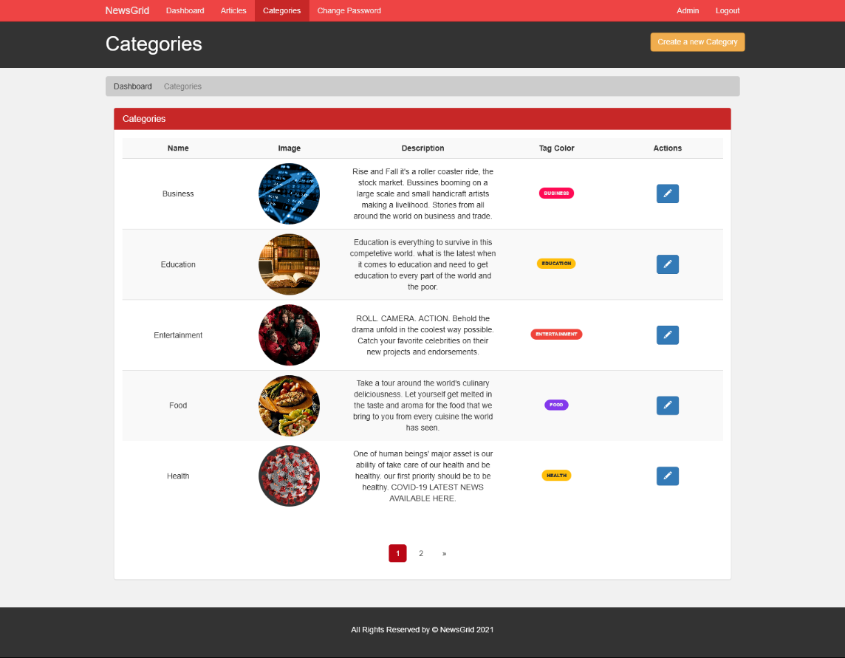](https://github.com/Anish-U/NewsGrid/blob/master/screenshots/adminPanelCategories.png)

Development setup

1. Retrieve the project (if you haven't done so already)

$ git clone https://github.com/Anish-U/NewsGrid.git

or download the project via GitHub

2. Move project folder to htdocs folder

if you cannot find the htdocs folder please follow the below links,

[Where to find htdocs in XAMPP Mac](https://stackoverflow.com/questions/45518021/where-to-find-htdocs-in-xampp-mac)

[Find htdocs path, no matter where file is stored](https://stackoverflow.com/questions/5536730/find-htdocs-path-no-matter-where-file-is-stored)

[htdocs path in linux](https://stackoverflow.com/questions/1582851/htdocs-path-in-linux)

[https://stackoverflow.com/questions/1582851/htdocs-path-in-linux](https://stackoverflow.com/questions/44989243/unable-to-find-htdocs-on-xampp)

3. Restore Database

Goto phpMyAdmin and create a Database names news-portal.

Now Select Import.

Find 'File to import:' section and choose the file 'news-portal.sql' which is located under project folder and hit GO.

4.Setup Database Configurations

Go to project folder -> includes -> database.inc.php.

Setup your configurations related to MySQL.

Eg: Server Name -> localhost, MySQL Username -> root.

5. Start Server

Start the server and run <http://localhost:8888/Folder_name/index.php> (replace the port number 8888 to your port).

Alternatively you can also run the command on your terminal

php -S localhost:8888 (replace the port number to your choice)

<https://github.com/Anish-U/NewsGrid>